Project Report

## Parallel and Distributed Computing

Group members:

* Hafsa Habib(59021)
* Ramisha Mukhtar(59116)
* Aqsa(59278)

Submitted to: Dr. Ayaz Khan

**Table of contents:**

|  |  |
| --- | --- |
| S.no. | Contents |
| i. | Introduction |
| ii. | Goals |
| iii. | Achievements |
| iv. | Individual Contribution |

1. **Introduction:**

The project is a client-server application. The server will provide a media-list to client which a client can play or download. These media files can be downloaded via WIFI or Ethernet or Internet. The client-server characteristic describes the relationship of cooperating programs in an application. The server component provides a media list containing media files to clients which initiate requests for such files to download or play. Media files are content in audio, video and image formats

.

1. **Goals:**

* Server will manage playlist and upload media files.
* Clients are shown the media list with options to open or download the files.
* The image files are of .jpeg, .png
* The audio files are of .mp3, .wma
* The video files are of .avi, .flv, .wmv, .mp4, .3gp

1. **Achievements:**

**Requirements Gathering:**

Requirement gathering phase of the project describes “**what**” features this project must have? I.e. uploading, downloading and streaming of media files in media list shown to client end by server end & communication of clients with server.

**Analysis:**

Analysis phase was all about the exploration of user interface according to the tools we will use that “**how**” server contains media list on server end will shown up at both server end and client end, its items in categories of media files such as audio, video and images & the subcategories of audio files, video files and image files. How the upload and open file options shown on client-end will perform (the backend logic) and how the communication between the client and server takes place.

**Design:**

The design phase of the project contain the implementation of view or user interface of the project.

* At server end:
* 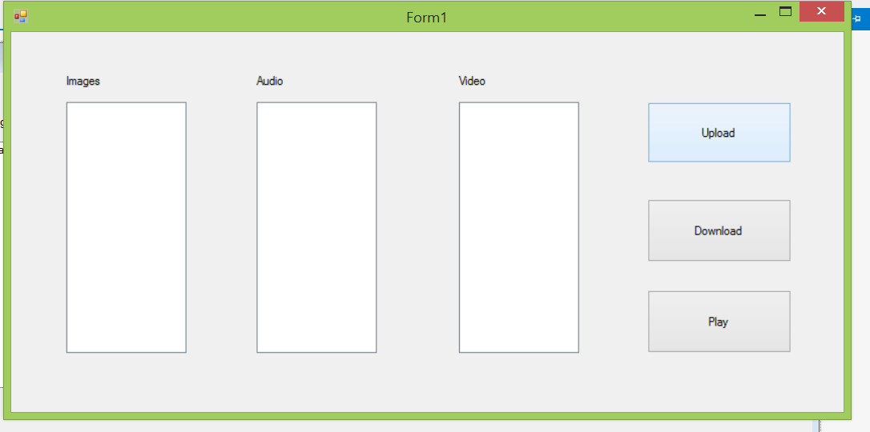
* 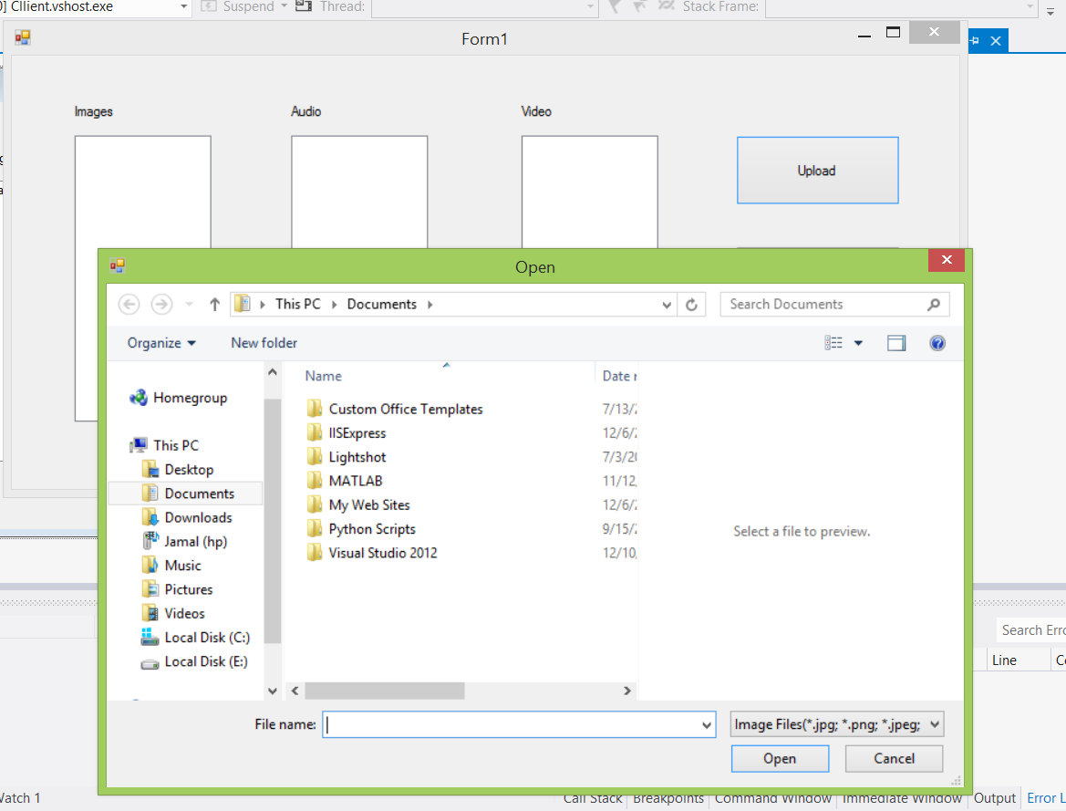

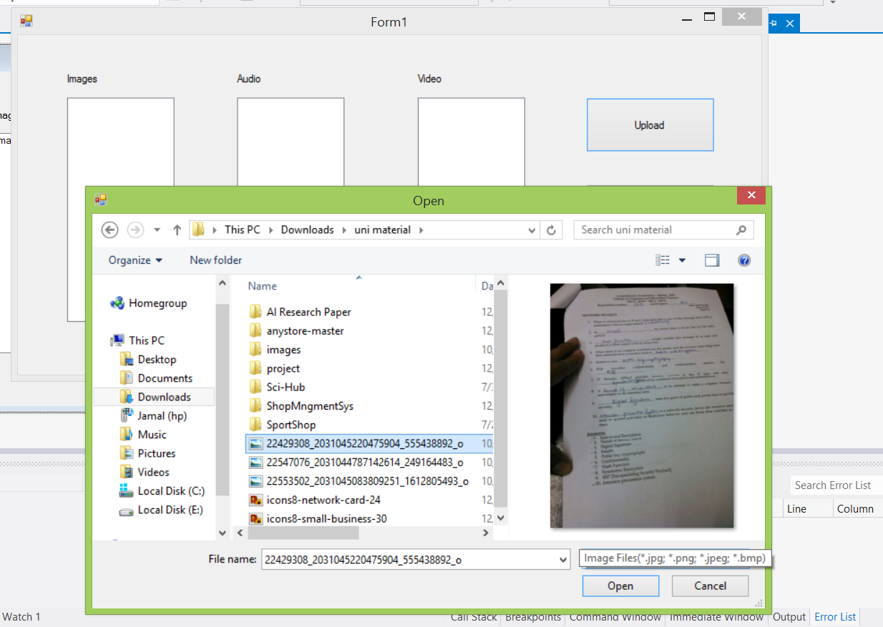

* Upload media list:

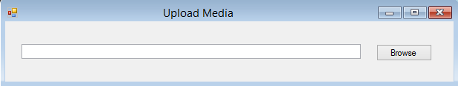

**Coding:**

In this phase we’ve started the client server communication after completion of handshaking process. Then the phase will move toward the media list uploading, downloading and opening(in case of image)/streaming(in case of audio/video)

(Socket connection for client server handshake – server end)

(Socket connection for client server handshake – client end)

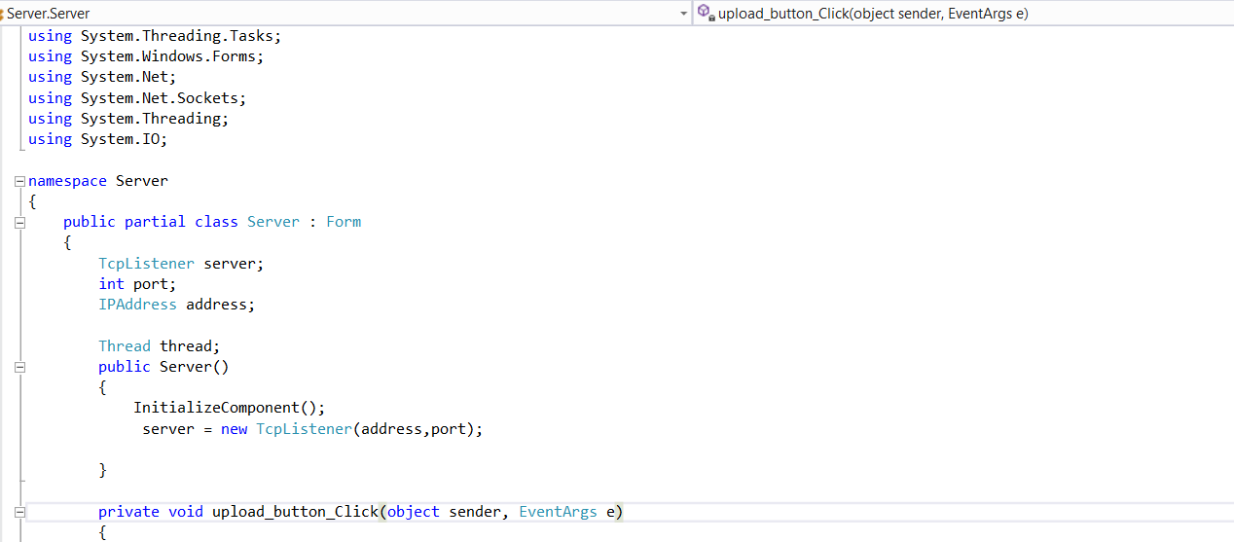

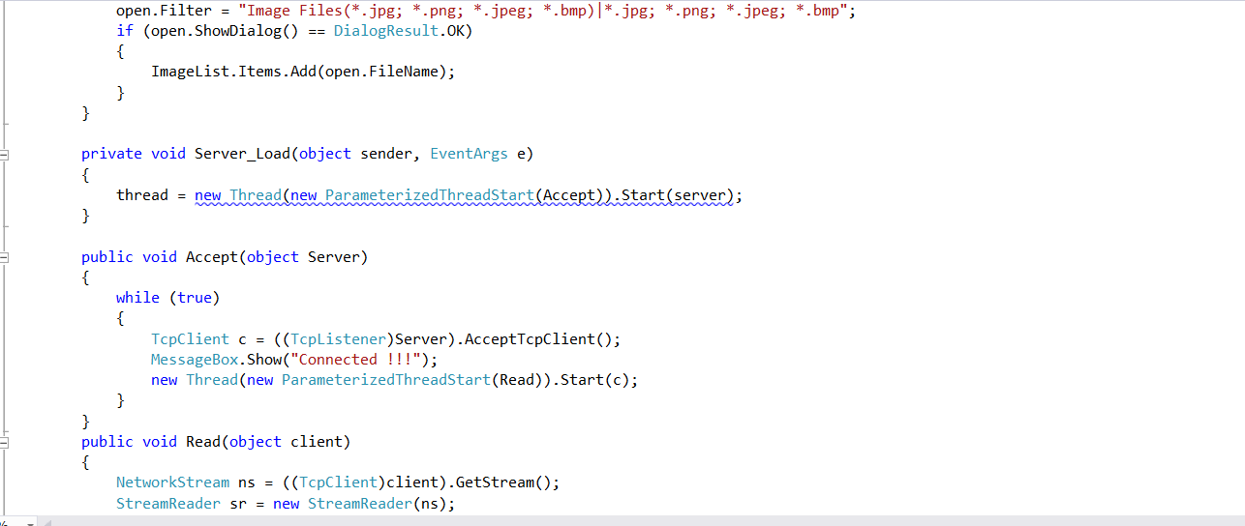

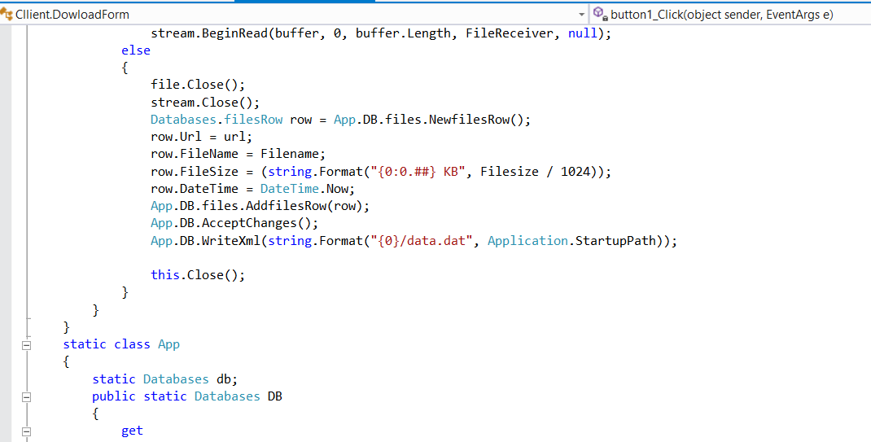

(Items on listboxes are uploaded according to media file category- both server and client end)

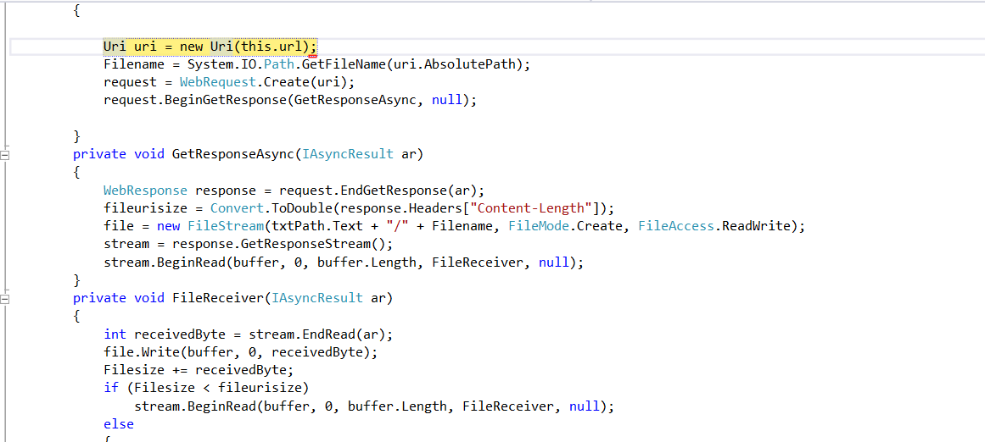

(Items from listboxes are open/played according to media file category- client end)

1. **Individual Contribution:**

*Hafsa Habib:* Designing of User Interface and backhand code of download

*Aqsa:* Requirements gathering & analysis

*Ramisha Mukhtar:* Coding